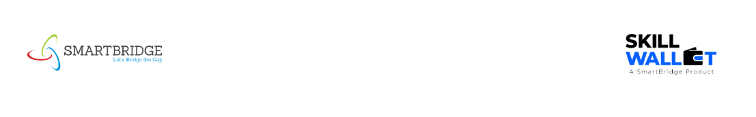

Communication

Date | 2 July 2026
Team ID | XXXXXX
Project Name | AI Powered Debt Relief & Financial Recovery Platform
Maximum Marks | 1 Mark

Communication Plan:
Effective communication is essential for a successful project demonstration. This document outlines the communication strategy used within the team and with stakeholders throughout the project lifecycle, including how updates, issues, and feedback were managed.
S.No | Communication Type | Frequency | Channel / Tool | Participants | Purpose
1 | Team Standup | Daily | Google Meet & WhatsApp | All Team Members | Discuss daily tasks and Progress.
2 | Progress Update | Weekly | GitHub & Goggle meet Teams | Team Lead & Members | Review completed epics & project progress and assign new work.
3 | Issue / Bug Discussion | As Needed | Whatsapp & VS Code Live Share. | Development Team | Resolve bugs and technical issues
4 | Stakeholder Review | Bi-Weekly | Google Meet | Team | Review project progress & Collect feedback.
5 | Final Demo Rehearsal | Once | Google Meet | Entire Team | Prepare final project demonstration.
6 | Documentation Review | Weekly | GitHub | Team Lead & Team Members | Verify project documents before submission.

Communication Challenges & Resolutions:
S.No | Challenge Faced | Resolution / Action Taken
1 | Coordinating & Team Members has different schedules. | Planned meetings in advance using WhatsApp and Google Meet.
2 | API integration issues between frontend and backend. | Used GitHub for version control , Collaborative debugging and testing.
3 | API configuration and debugging problems. | Tested modules individually fallback/ error handling.

